concurrency: Concurrency is the ability of a program to handle multiple orders or requests. Where each incoming order or request can be stacked / burdened by one process. We analogize a process as a waitress. Based on the concept of concurrency, the waiter has the ability to handle multiple outstanding orders. The waiter could have taken all the orders and stacked them into one.
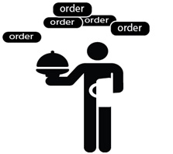

parallel : the ability of a program to handle more than one order/request simultaneously. We use the same analogy, which is a restaurant waiter. In Parallelism, we have many servers (think of as threading/sub-processes) that can help handle incoming requests so that the process is faster so that incoming orders/requests are processed/handled faster.
